Project Plan

Project Databases, Mathematical Engineering year 1

The search group:

José Moreno Mendes

Niels de Jong

Hugo Antunes Cabral

Jesse Tijsterman

Kawai Cheung

Thursday, May 17, 2018

Version 1.0

Table of contents

1. Introduction…………………………………………………………………………………………..3

2. Context………………………………………………………………………………………………….3

2.1 Situation………………………………………………………………………………………..3

2.2 Problem statement………………………………………………………………………...4

3. Goals and objectives……………………………………………………………………………….5

3.1Project goals and objectives…………………………………………………………….5

4. Methodology………………………………………………………………………………………….5

4.1 Research strategy…………………………………………………………………………..5

5. Risks and solution………………………………………………………………………………….6

6. Task division………………………………………………………………………………………….6

6.1 Task division and planning……………………………………………………………6

7. Contact information………………………………………………………………………………7

7.1 References…………………………………………………………………………………...7

1.0 INTRODUCTION

The Search Project Plan will provide a definition of the project, including the project’s goals and objectives. This project report, it is about the general skills obtained at the course of Mathematical Engineering at Inholland Universiity, during the first year. The Search group is composed of five members who are:

José Moreno Mendes, Niels de Jong, Jesse Tijsterman, Kawai Cheung and Hugo Antunes Cabral. The main task of the project is to create a web application that provides information about a specific subject.

2. CONTEXT

Amsterdam is famous of freedom and liberty, the drugs accessibility it is quite easy and as consequence it brings some problems to people, especially tourists.

This project will focus on providing a detailed web application, which can inform and aware people about the drugs, in special the affects, medical information and the rules.

2.1 **Situation**

The Dutch Central Bureau of statistics includes the trade of illegal activities in the Dutch GDP. A few examples of these illegal activities: xtc, cocaine, heroin, smuggling, etc. The trade in these illegal activities are estimated by the Dutch Central Bureau of statistics based on police sources.

The graph shows the trade in legal and illegal activities. According to the Bureau of statistics the trade in cannabis is 1.04 billion euro.

The graph gives an idea of how many people are consuming drugs every year in Netherlands.

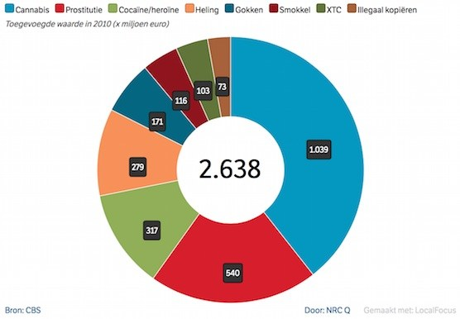

Source: www.amsterdamredlightdistricttour.com

2.2 **Problem statement**

The main problem of drugs in Netherlands and Amsterdam, is that people are consuming them without any knowledge of the consequences of it. Specially the consequences of health and rules.

3. GOALS AND OBJECTIVES

3.1 **Project Goals and Objectives**

The project goal is to provide a web application with some information related of the relationship between drugs and Amsterdam. Providing the general and specific knowledge as medical information and rules.

- Create a Web application.

- Enhances the ability and effectiveness of group members.

- Provide enough information for visitor to Amsterdam.

- Provides high levels of data.

- Facilitates the access of medical and law information.

- Accomplish project goals and objectives within time parameters.

4. METHODOLOGY

The Search group will use a qualitative research to collect the data. A data matrix will be used to become clear what are the units of analysis and what the constructs of the units of analysis.

4.1 **Research strategy**

The strategy is to collect data with open interviews and participant observation, using existing documents and new forms. Afterwards analyze the problems based on the situation, events and person.

5. RISKS AND SOLUTIONS

To anticipate, avoiding major risks and mitigating the effects of others, the group is aware of the risks. As a team we will work our best to manage them. For every risk there is a solution, for every question there is an answer.

|  |  |  |  |
| --- | --- | --- | --- |
| **RISKS** | **RISKS LEVEL**  **L/M/H** | **LIKELIHOOD OF EVENT** | **MITIGATION**  **STRATEGY** |
| Person Hours | **H:** Over 40 hours | Certainty | Assigned Project Manager, comprehensive project approach and communications plan |
| Estimated Project Schedule | **H:** 11 weeks | Certainty | Create comprehensive project timeline with frequent baseline review |
| Team Size at Peak | **M:** 5 members | Certainty | Comprehensive communications plan, frequent meetings |
| Project Team’s Shared Work Experience creates poor working relationship | **H:** Members have never worked together | Some  what likely | Comprehensive Communication plan |

6. TASK DIVISION AND PLANNING

6.1 **Task division and planning**

The Search group have divided the tasks between the group members, meanwhile all the members have agreed to help each other when there is a need.

According with the agreements, Niels and José will be responsible with the programming part meanwhile, Hugo, Jesse and Kawai will collect the data and be responsible with the database. All the members will check each others work making sure all work out well.

7. CONTACT INFORMATION

The Search members:

José Moreno Mendes: [578148@student.inholland.nl](mailto:578148@student.inholland.nl)

Niels de Jong: [581276@student.inholland.nl](mailto:581276@student.inholland.nl)

Hugo Antunes Cabral: [619627@student.inholland.nl](mailto:619627@student.inholland.nl)

Jesse Tijsterman: [622251@student.inholland.nl](mailto:622251@student.inholland.nl)

Kawai Cheung: [614933@student.inholland.nl](mailto:614933@student.inholland.nl)

7.1 **References**

The search group is using mostly the web browser to obtain information about the data and improve the knowledge skills towards the project.

[www.w3school.com](http://www.w3school.com)

[www.codeacademy.com](http://www.codeacademy.com)

[www.politie.nl](http://www.politie.nl)

[www.ggd.amsterdam.nl](http://www.ggd.amsterdam.nl)

[www.ggznederland.nl](http://www.ggznederland.nl)

[www.jellinek.nl](http://www.jellinek.nl)

[www.amsterdamredlightdistrict.com](http://www.amsterdamredlightdistrict.com)